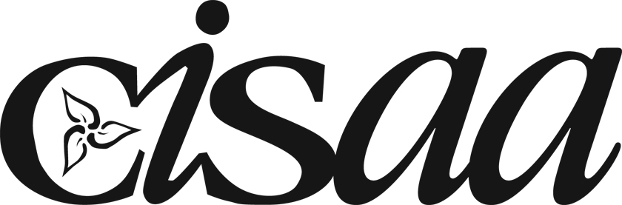
Conference of Independent Schools Athletic Association

Respect... rules, officials, opponents, team, self
Honour the game!

CISAA
Parents’ Workshop Invitation
2016

The Conference of Independent Schools’ Athletic Association will be proudly presenting a very informative workshop for parents of our male and female student/athletes. The workshop will be hosted on Tuesday, April 5th, 2016 from 7:00-8:15pm in George Weston Hall (Upper Canada College Preparatory School – see map link below). Best of all, there will be no cost to attend.

“The Second-Goal Parent: Developing Winners in Life Through Sports” (75 minutes)
This interactive workshop explores the role of a Second-Goal parent, supporting their child so that he or she enjoys a positive experience in sports.

Topics discussed include:
- How parents can help ensure their student-athletes’ experience healthy, developmental (physical, social, mental) outcomes that will serve them far beyond the playing field
- Guidelines for developing a positive Coach/Parent relationship
- Understanding the research-based three stages of Talent Development
- Engaging children in constructive, meaningful conversations
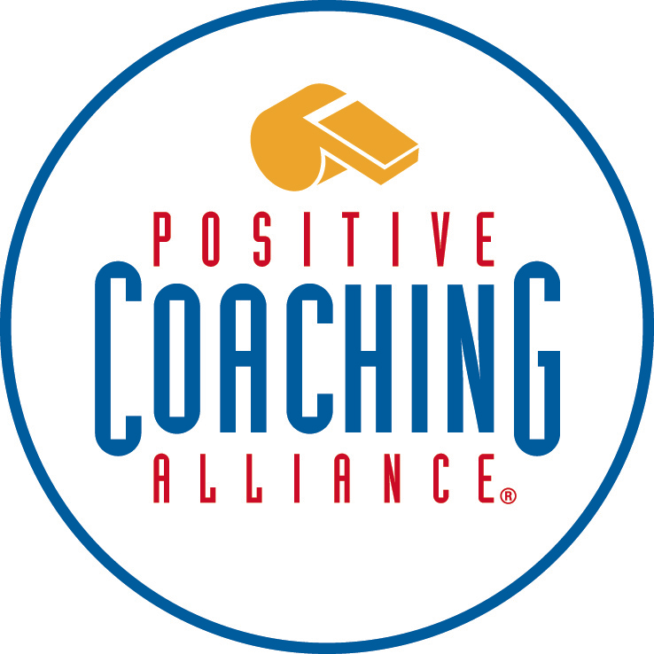
- Insight into the training of coaches and what it means to be a Double-Goal Coach

RSVP is required as booklets for all participants need to be ordered.

Please click on the link below to register.

Register Here.

Link to Campus Map

