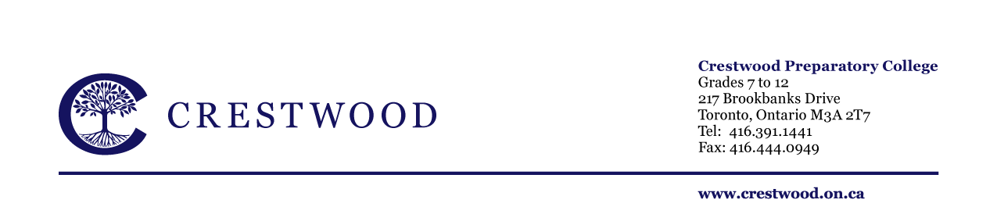
CRESTWOOD’S FOURTH ANNUAL CO-ED BASKETBALL EVENT
GRADES 4-8
FRIDAY JANUARY 16, 2015
Dear Parents,

On Friday January 16th 2015, all basketball players from Grades 4 through 8 are invited to attend our fourth Annual Crestwood Co-ed Basketball Event at Crestwood Preparatory College. Competitors will take part in a 3 on 3 competition starting at 3:30pm followed by an exciting multi-grade exhibition basketball game at approximately 4:15pm.

All students who were or currently are members of a Crestwood Basketball team this year are invited to participate in the event (all male and female U10-U12 players at the Lower School and all male and female U14 players at the Upper School).

Following the game all players and spectators (parents, siblings) are invited to a join us in the cafeteria for a burger and drink.

All players and their coaches from the Lower School will travel by bus to the Upper School (depart 2:45). All students should be picked up from the Upper School by parents at approximately 6:00pm.

All participants and spectators are asked to RSVP by email to either Sherri Brenzel (Lower School) and / or Lisa Newton (Upper School) by Monday January 12th, 2015. Your response is required in order to assist us in organizing the buses and dinner. Please indicate in your response;
- Students name
- Grade
- If they require transportation to the Upper School
- Number of individuals staying for the BBQ (players, parents, siblings)

If you have any questions about the event please feel free to contact Lisa Newton or Sherri Brenzel for more information. We hope to see you all there!

Sincerely,

Lower School Responses Sherri Brenzel sherri.brenzel@crestwood.on.ca
Upper School Responses Lisa Newton lisa.newton@crestwood.on.ca

